1. Create one IAM user and assign ec2,s3 full access role.

1. Create one Group in IAM and Assign Read access for ec2.

1. Create a new user with name Devops and add to the group created in task2.

1. Write a bash script to create a IAM user with VPC full access.

Step1: create an iam role with vpc full access

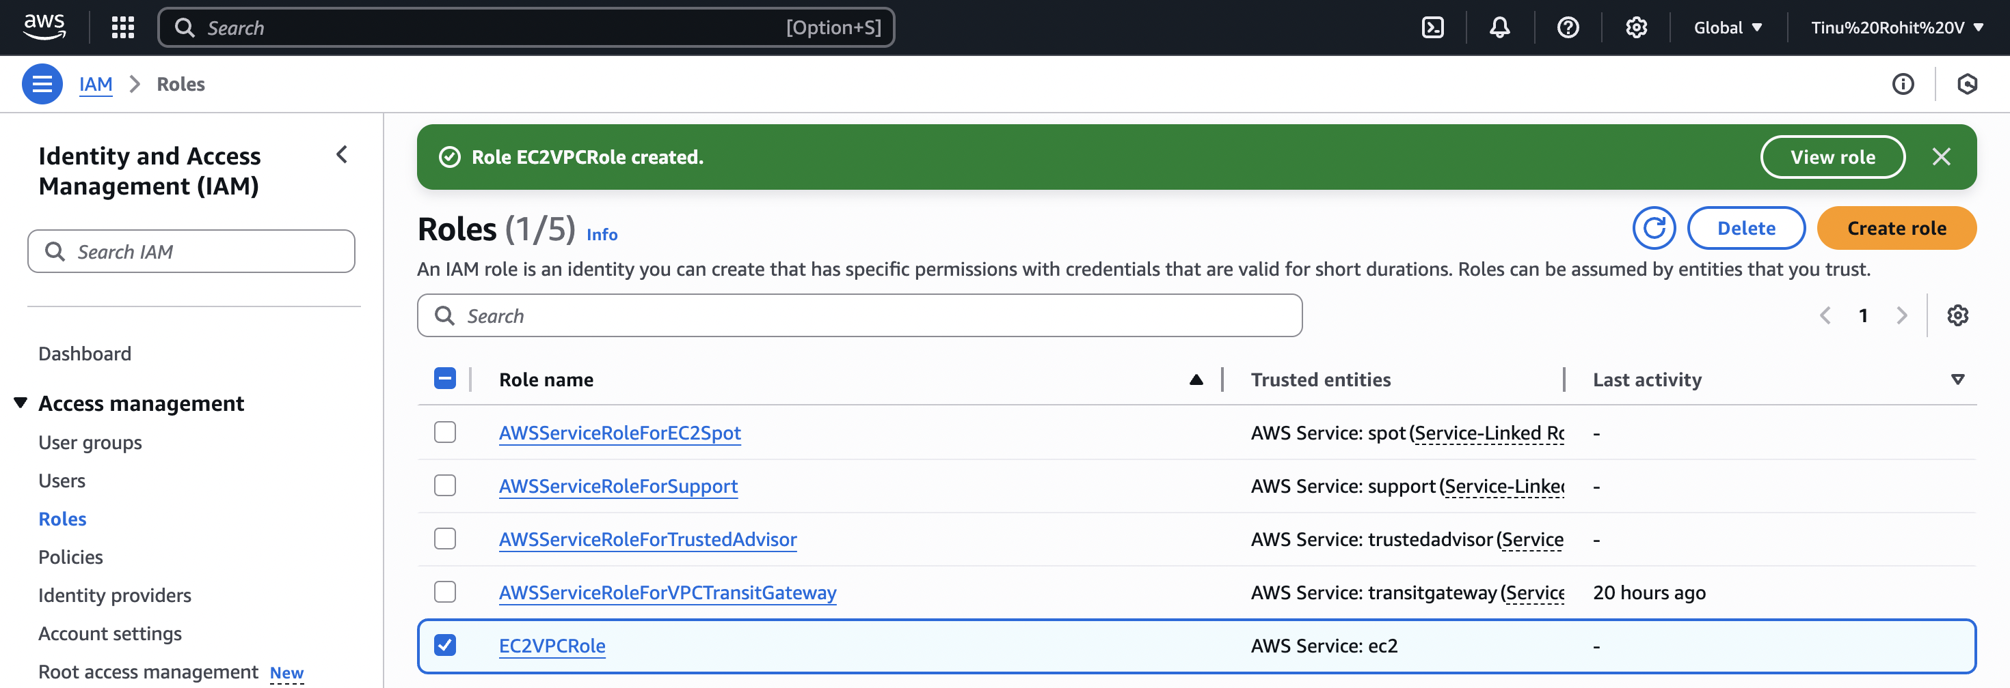

Step 2: Launch ec2 instance with IAM role

Step 3: create a bash script to run

Step 4: run the script to create user and give full vpc access

1. Create a IAM policy to access ec2 for a specific user in specific regions only.

1. We have two accounts Account A and Account B, Account A user should access s3 bucket in Account B.

